# **Configure an SSL Binding**

In this exercise, you will configure an SSL binding. You will need an SSL certificate in order to complete these steps.

**Note:** Azure App Service requires that your certificate be in PFX format.

## **Task 1: Upload the SSL Certificate**

Before you can add an SSL binding, you need to upload a certificate to your Web App.

1. Open your Web App in the Azure portal.
2. In the menu, click **SSL Settings**.
3. Scroll down and click **Upload Certificate**.

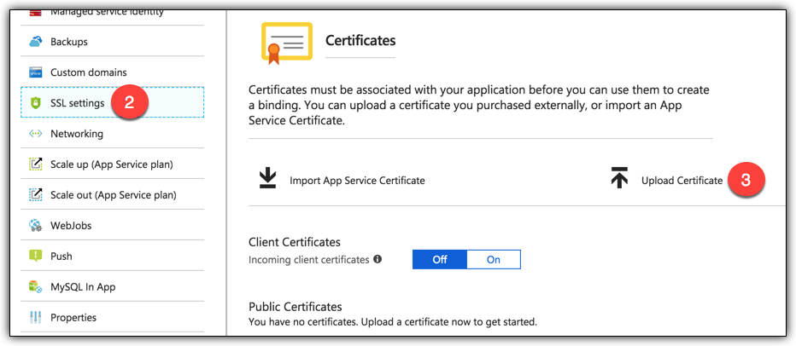

1. Make sure **Private** is selected. (Public certificates are designed to be used in code and are not for SSL bindings.)
2. Click in PFX Certificate File and browse to the PFX certificate.
3. Enter the password for the certificate.
4. Click **Upload** to upload the certificate.

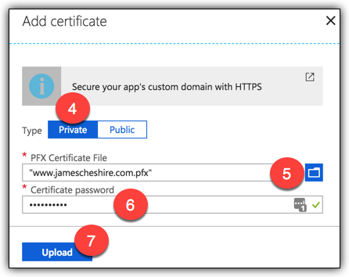

Once the certificate successfully uploads, you’ll see it listed in the list of private certificates in the Azure portal.

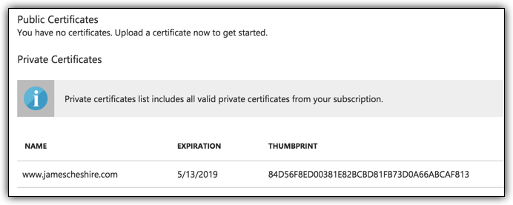

## **Task 2: Add an SSL Binding**

Once you have uploaded an SSL certificate, you can create an SSL binding that uses the certificate.

1. In the SSL Settings blade, click **Add Binding**.
2. Select the hostname you want to add a binding for.
3. Select the certificate you want to use. Note that only certificates that match the hostname you selected will be shown.
4. Select your binding type. App Service supports both SNI-based and IP-based bindings.
5. Click **Add Binding** to complete the SSL binding.

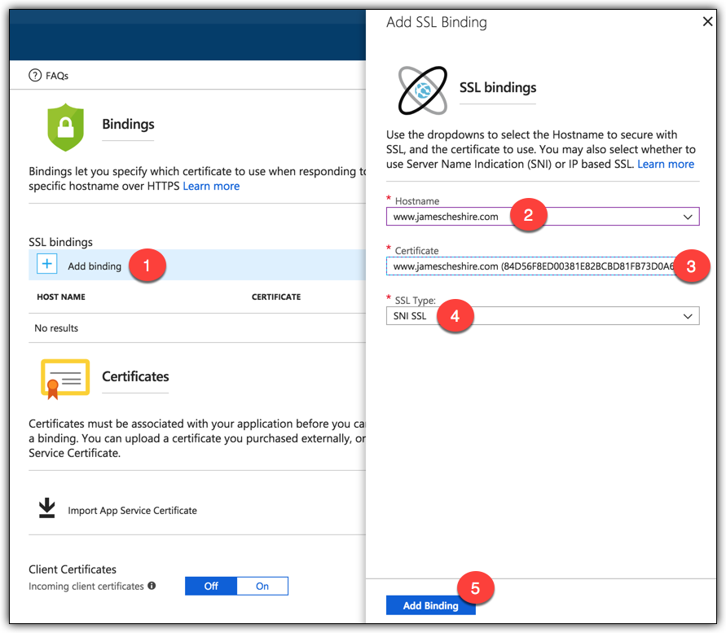

You can now browse to your Web App’s custom domain using SSL.